DATA 621 – Business Analytics and Data Mining Homework 1

14/09/2019

# 1. DATA EXPLORATION

There are 16 variables and 2,276 observations in the training data.

## Observations: 2,276  
## Variables: 16  
## $ TARGET_WINS <dbl> 39, 70, 86, 70, 82, 75, 80, 85, 86, 76, 78, 68,…  
## $ TEAM_BATTING_H <dbl> 1445, 1339, 1377, 1387, 1297, 1279, 1244, 1273,…  
## $ TEAM_BATTING_2B <dbl> 194, 219, 232, 209, 186, 200, 179, 171, 197, 21…  
## $ TEAM_BATTING_3B <dbl> 39, 22, 35, 38, 27, 36, 54, 37, 40, 18, 27, 31,…  
## $ TEAM_BATTING_HR <dbl> 13, 190, 137, 96, 102, 92, 122, 115, 114, 96, 8…  
## $ TEAM_BATTING_BB <dbl> 143, 685, 602, 451, 472, 443, 525, 456, 447, 44…  
## $ TEAM_BATTING_SO <dbl> 842, 1075, 917, 922, 920, 973, 1062, 1027, 922,…  
## $ TEAM_BASERUN_SB <dbl> NA, 37, 46, 43, 49, 107, 80, 40, 69, 72, 60, 11…  
## $ TEAM_BASERUN_CS <dbl> NA, 28, 27, 30, 39, 59, 54, 36, 27, 34, 39, 79,…  
## $ TEAM_BATTING_HBP <dbl> NA, NA, NA, NA, NA, NA, NA, NA, NA, NA, NA, NA,…  
## $ TEAM_PITCHING_H <dbl> 9364, 1347, 1377, 1396, 1297, 1279, 1244, 1281,…  
## $ TEAM_PITCHING_HR <dbl> 84, 191, 137, 97, 102, 92, 122, 116, 114, 96, 8…  
## $ TEAM_PITCHING_BB <dbl> 927, 689, 602, 454, 472, 443, 525, 459, 447, 44…  
## $ TEAM_PITCHING_SO <dbl> 5456, 1082, 917, 928, 920, 973, 1062, 1033, 922…  
## $ TEAM_FIELDING_E <dbl> 1011, 193, 175, 164, 138, 123, 136, 112, 127, 1…  
## $ TEAM_FIELDING_DP <dbl> NA, 155, 153, 156, 168, 149, 186, 136, 169, 159…

Summary Statistics of the variables

Table continues below

|  |  |  |  |  |  |
| --- | --- | --- | --- | --- | --- |
| TARGET_WINS | TEAM_BATTING_H | TEAM_BATTING_2B | TEAM_BATTING_3B | TEAM_BATTING_HR | TEAM_BATTING_BB |
| Min. : 0.00 | Min. : 891 | Min. : 69.0 | Min. : 0.00 | Min. : 0.00 | Min. : 0.0 |
| 1st Qu.: 71.00 | 1st Qu.:1383 | 1st Qu.:208.0 | 1st Qu.: 34.00 | 1st Qu.: 42.00 | 1st Qu.:451.0 |
| Median : 82.00 | Median :1454 | Median :238.0 | Median : 47.00 | Median :102.00 | Median :512.0 |
| Mean : 80.79 | Mean :1469 | Mean :241.2 | Mean : 55.25 | Mean : 99.61 | Mean :501.6 |
| 3rd Qu.: 92.00 | 3rd Qu.:1537 | 3rd Qu.:273.0 | 3rd Qu.: 72.00 | 3rd Qu.:147.00 | 3rd Qu.:580.0 |
| Max. :146.00 | Max. :2554 | Max. :458.0 | Max. :223.00 | Max. :264.00 | Max. :878.0 |
| NA | NA | NA | NA | NA | NA |

Table continues below

|  |  |  |  |  |  |  |  |  |
| --- | --- | --- | --- | --- | --- | --- | --- | --- |
| TEAM_BATTING_SO | TEAM_BASERUN_SB | | TEAM_BASERUN_CS | TEAM_BATTING_HBP | | TEAM_PITCHING_H | | TEAM_PITCHING_HR |
| Min. : 0.0 | Min. : 0.0 | | Min. : 0.0 | Min. :29.00 | | Min. : 1137 | | Min. : 0.0 |
| 1st Qu.: 548.0 | 1st Qu.: 66.0 | | 1st Qu.: 38.0 | 1st Qu.:50.50 | | 1st Qu.: 1419 | | 1st Qu.: 50.0 |
| Median : 750.0 | Median :101.0 | | Median : 49.0 | Median :58.00 | | Median : 1518 | | Median :107.0 |
| Mean : 735.6 | Mean :124.8 | | Mean : 52.8 | Mean :59.36 | | Mean : 1779 | | Mean :105.7 |
| 3rd Qu.: 930.0 | 3rd Qu.:156.0 | | 3rd Qu.: 62.0 | 3rd Qu.:67.00 | | 3rd Qu.: 1682 | | 3rd Qu.:150.0 |
| Max. :1399.0 | Max. :697.0 | | Max. :201.0 | Max. :95.00 | | Max. :30132 | | Max. :343.0 |
| NA’s :102 | NA’s :131 | | NA’s :772 | NA’s :2085 | | NA | | NA |
| TEAM_PITCHING_BB | | TEAM_PITCHING_SO | | | TEAM_FIELDING_E | | TEAM_FIELDING_DP | |
| Min. : 0.0 | | Min. : 0.0 | | | Min. : 65.0 | | Min. : 52.0 | |
| 1st Qu.: 476.0 | | 1st Qu.: 615.0 | | | 1st Qu.: 127.0 | | 1st Qu.:131.0 | |
| Median : 536.5 | | Median : 813.5 | | | Median : 159.0 | | Median :149.0 | |
| Mean : 553.0 | | Mean : 817.7 | | | Mean : 246.5 | | Mean :146.4 | |
| 3rd Qu.: 611.0 | | 3rd Qu.: 968.0 | | | 3rd Qu.: 249.2 | | 3rd Qu.:164.0 | |
| Max. :3645.0 | | Max. :19278.0 | | | Max. :1898.0 | | Max. :228.0 | |
| NA | | NA’s :102 | | | NA | | NA’s :286 | |

Box plot of the data

From the following box plots of the variables we can see that the following variables have outliers

[1] "TARGET_WINS" "TEAM_BATTING_H" "TEAM_BATTING_2B" "TEAM_BATTING_3B" "TEAM_BATTING_BB"

[6] "TEAM_BASERUN_SB" "TEAM_BASERUN_CS" "TEAM_BATTING_HBP" "TEAM_PITCHING_HR" "TEAM_PITCHING_BB"

[11] "TEAM_PITCHING_SO" "TEAM_FIELDING_E" "TEAM_FIELDING_DP".

Other variables don’t have any outlier.

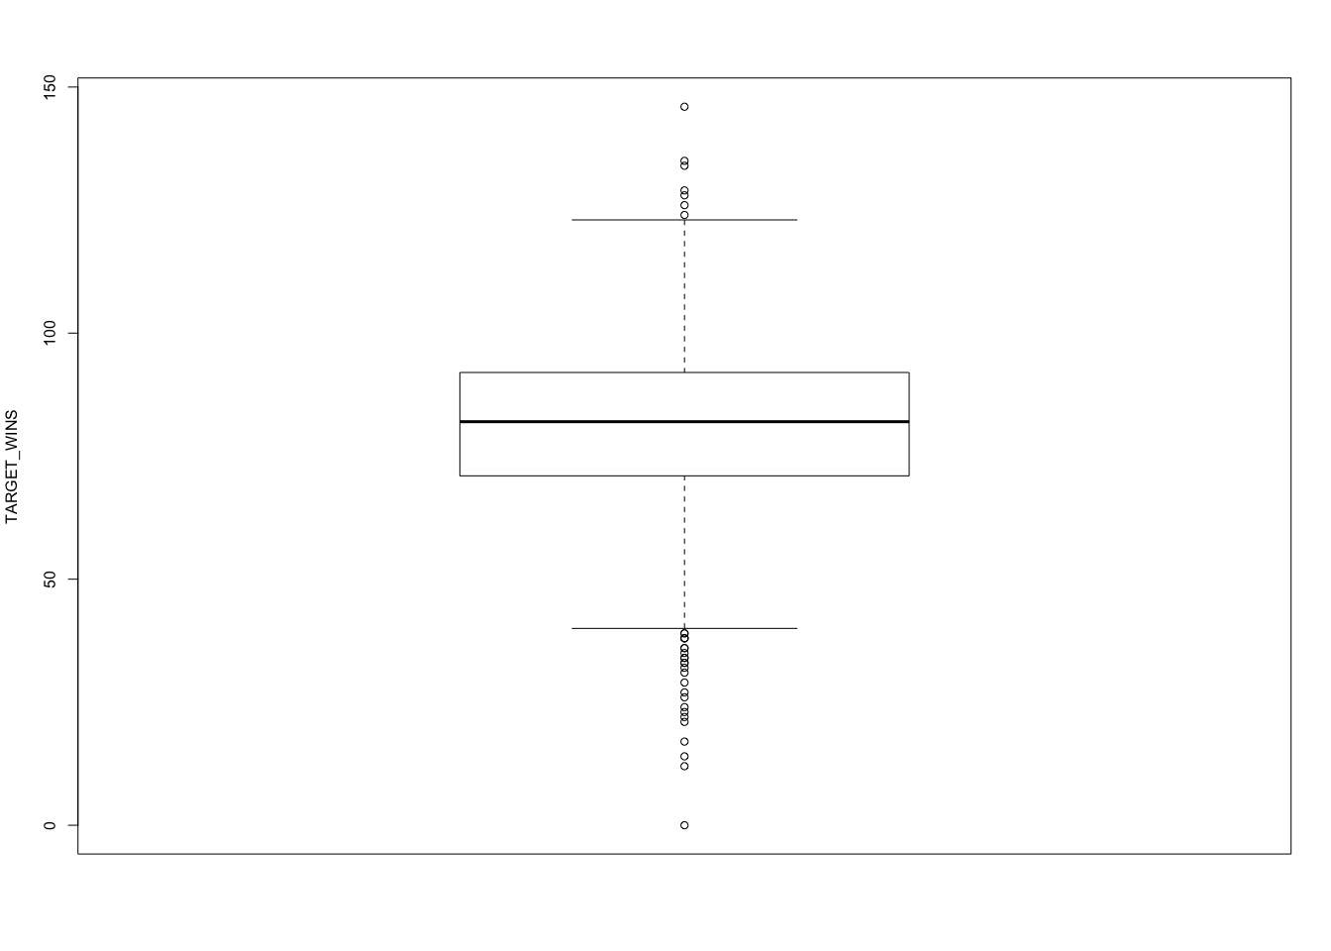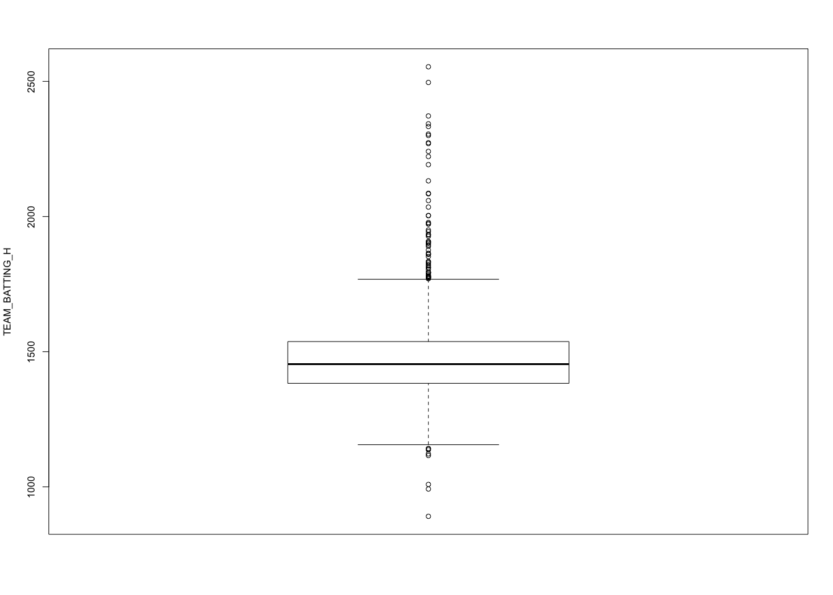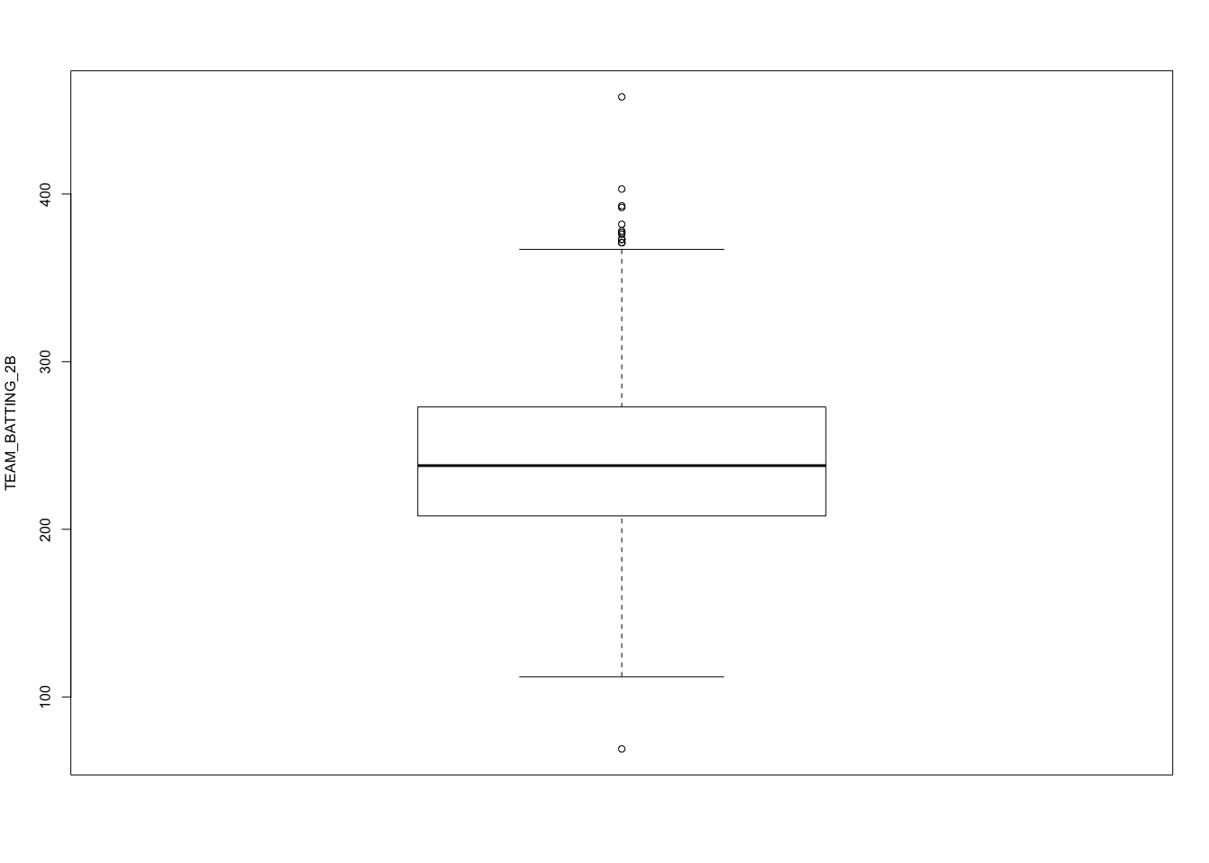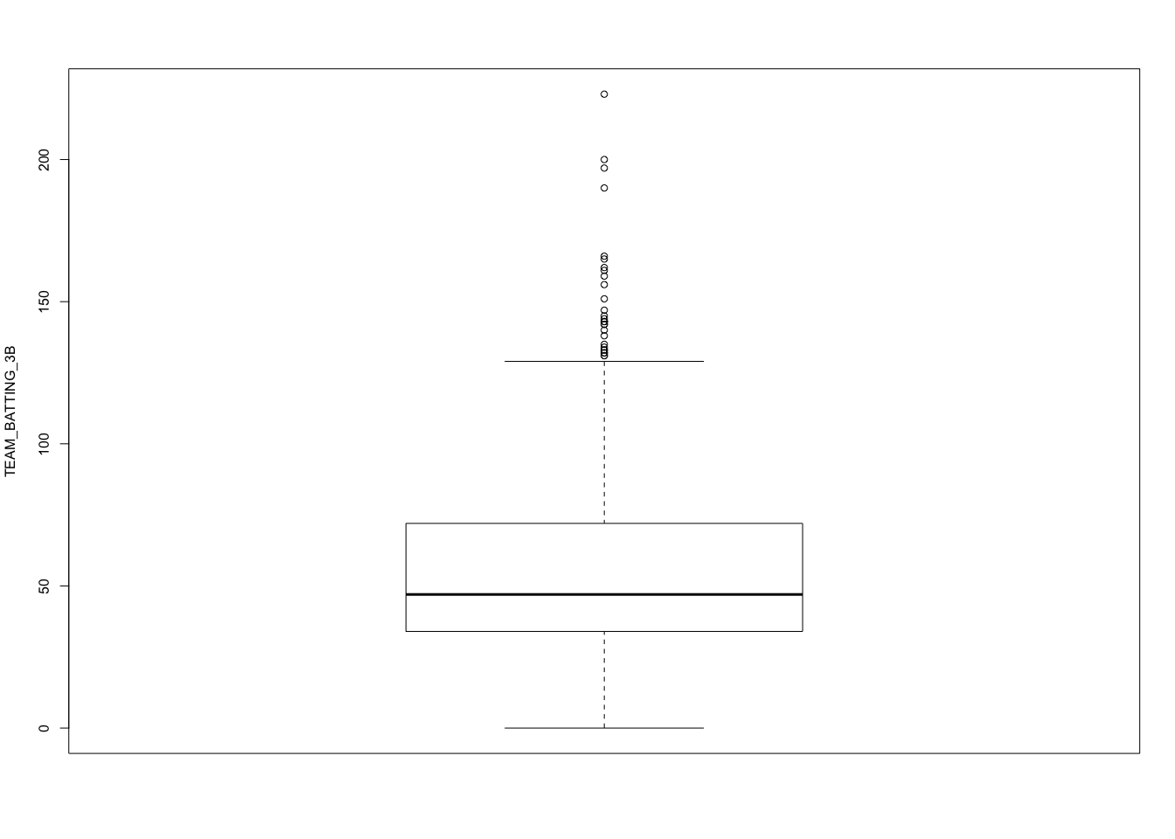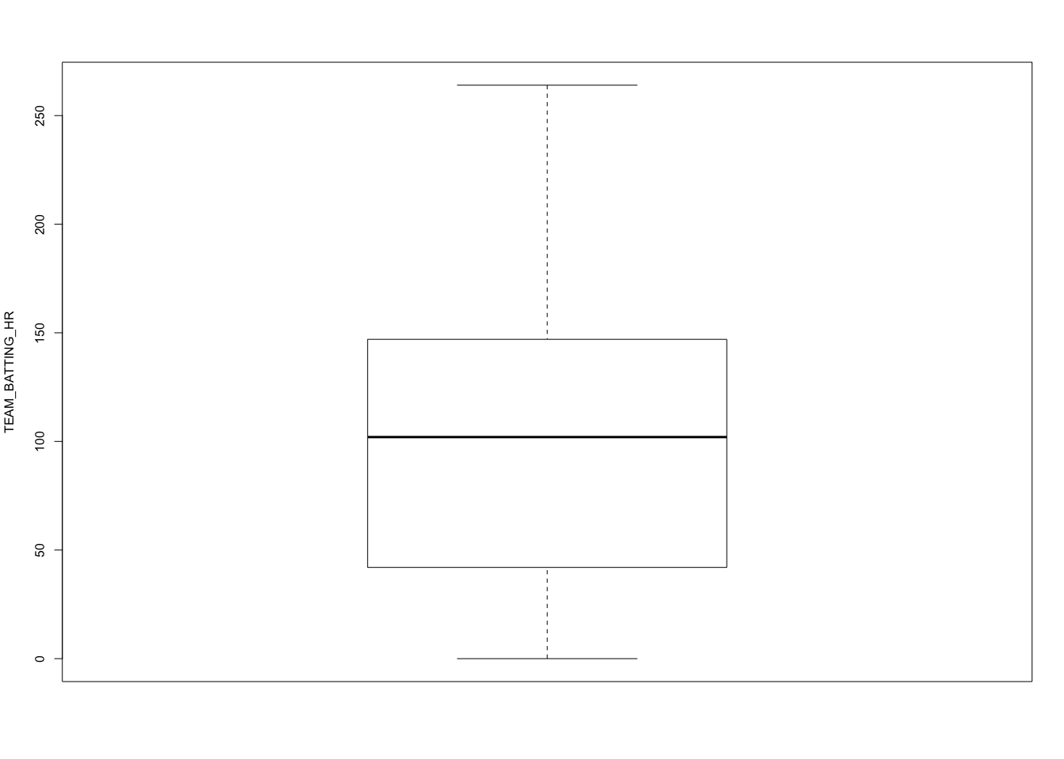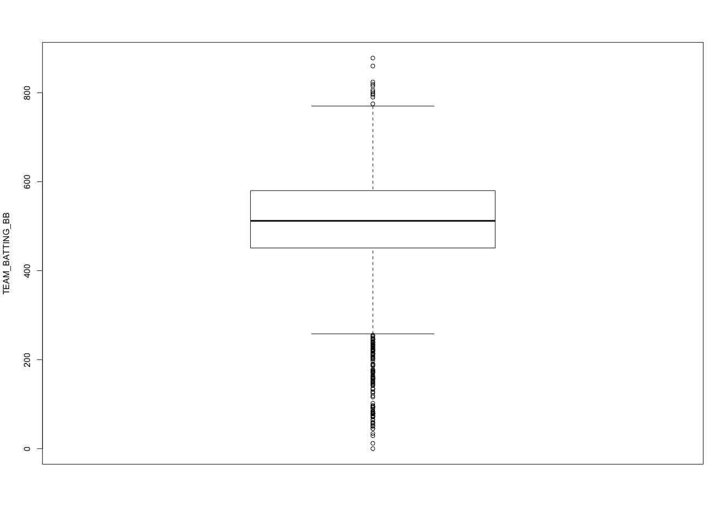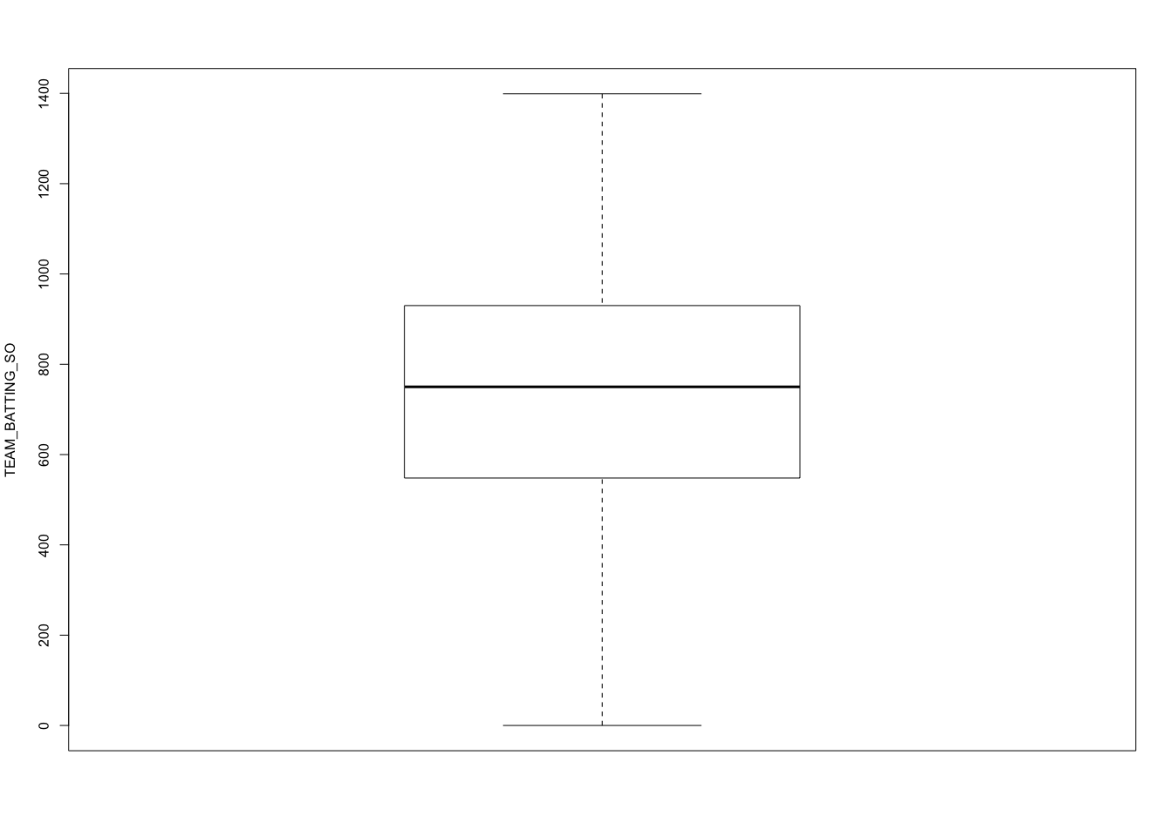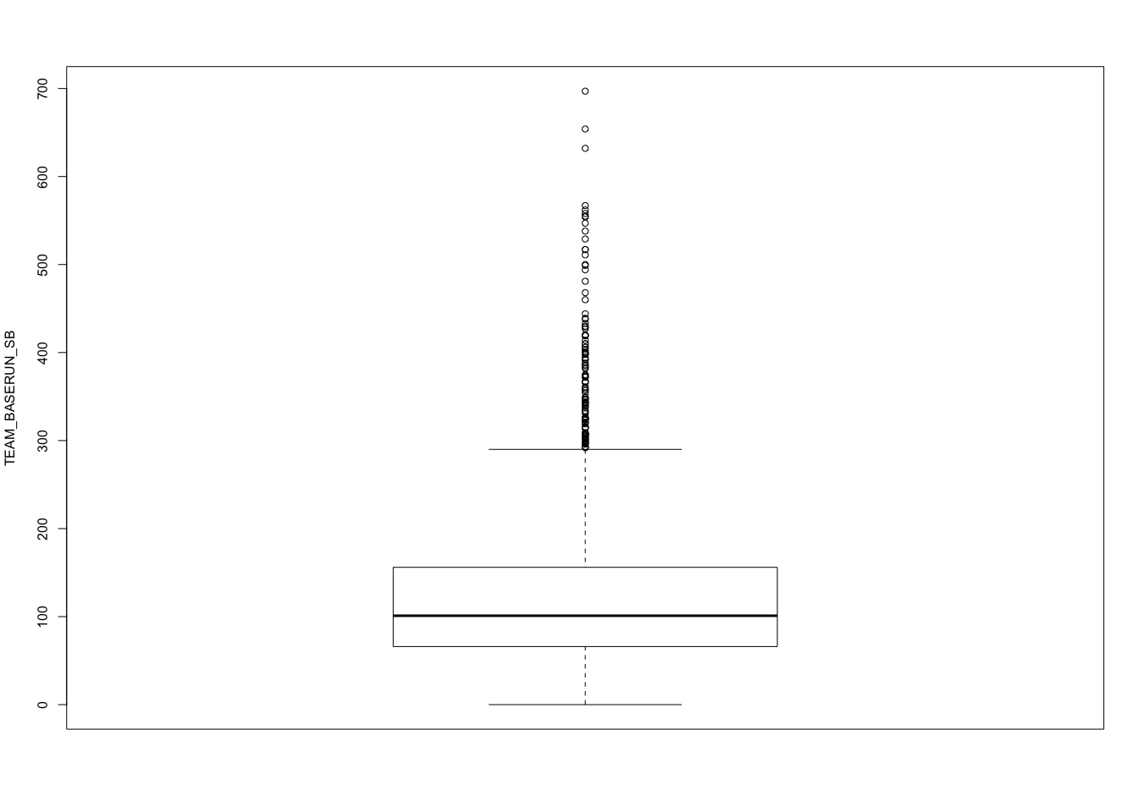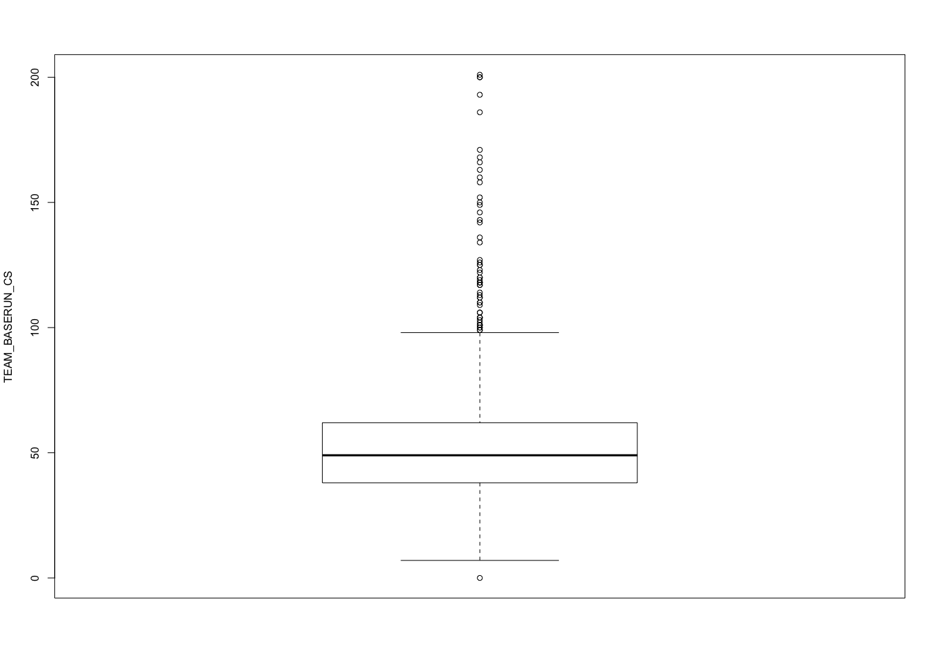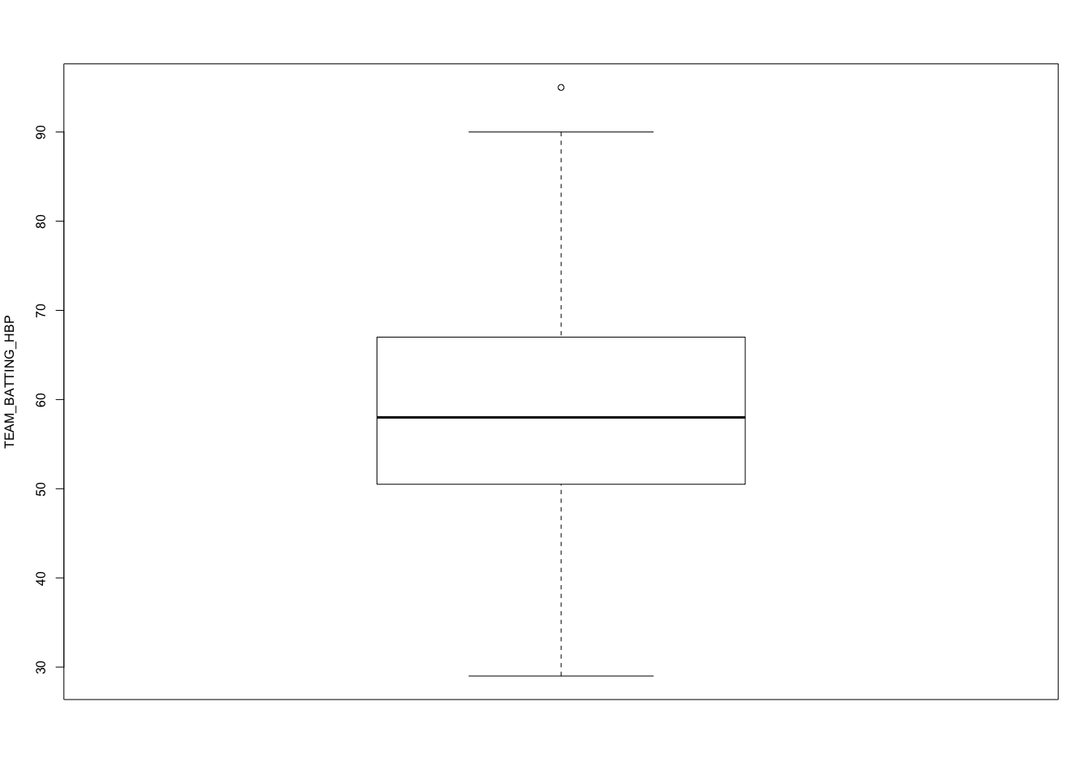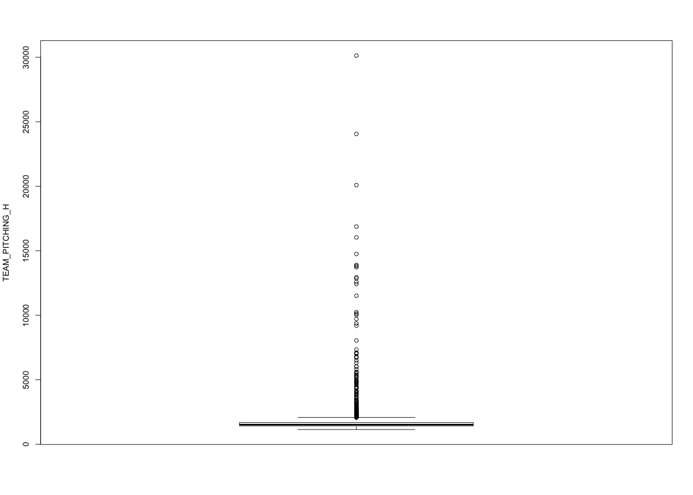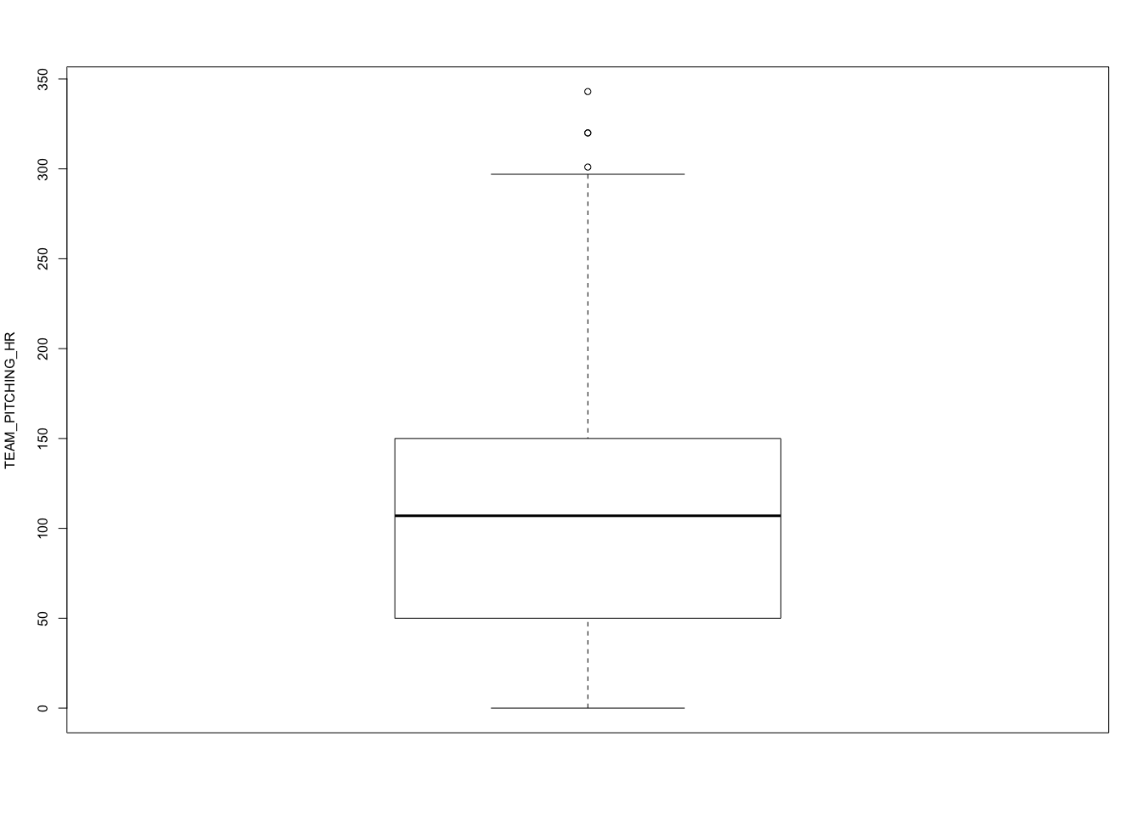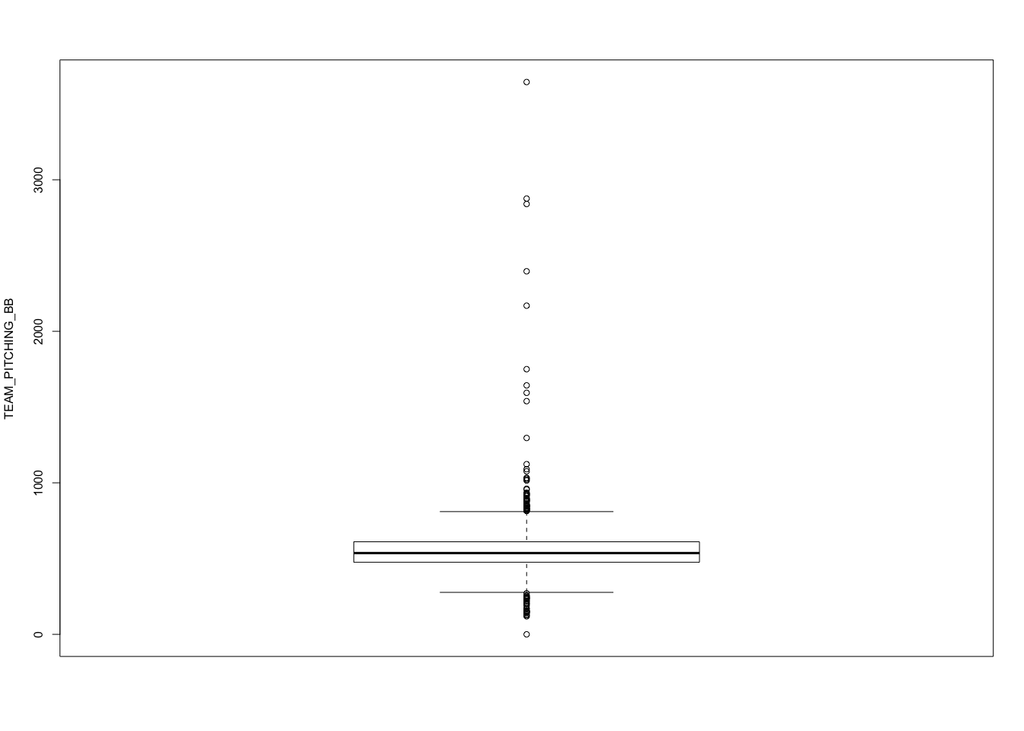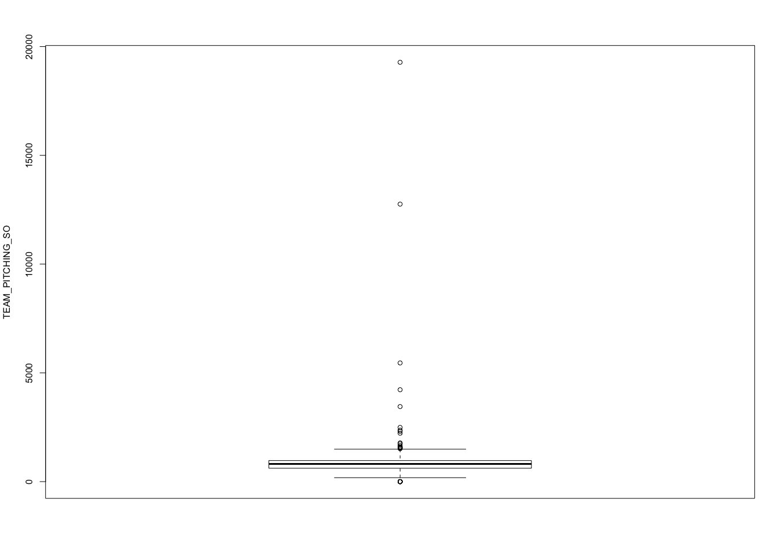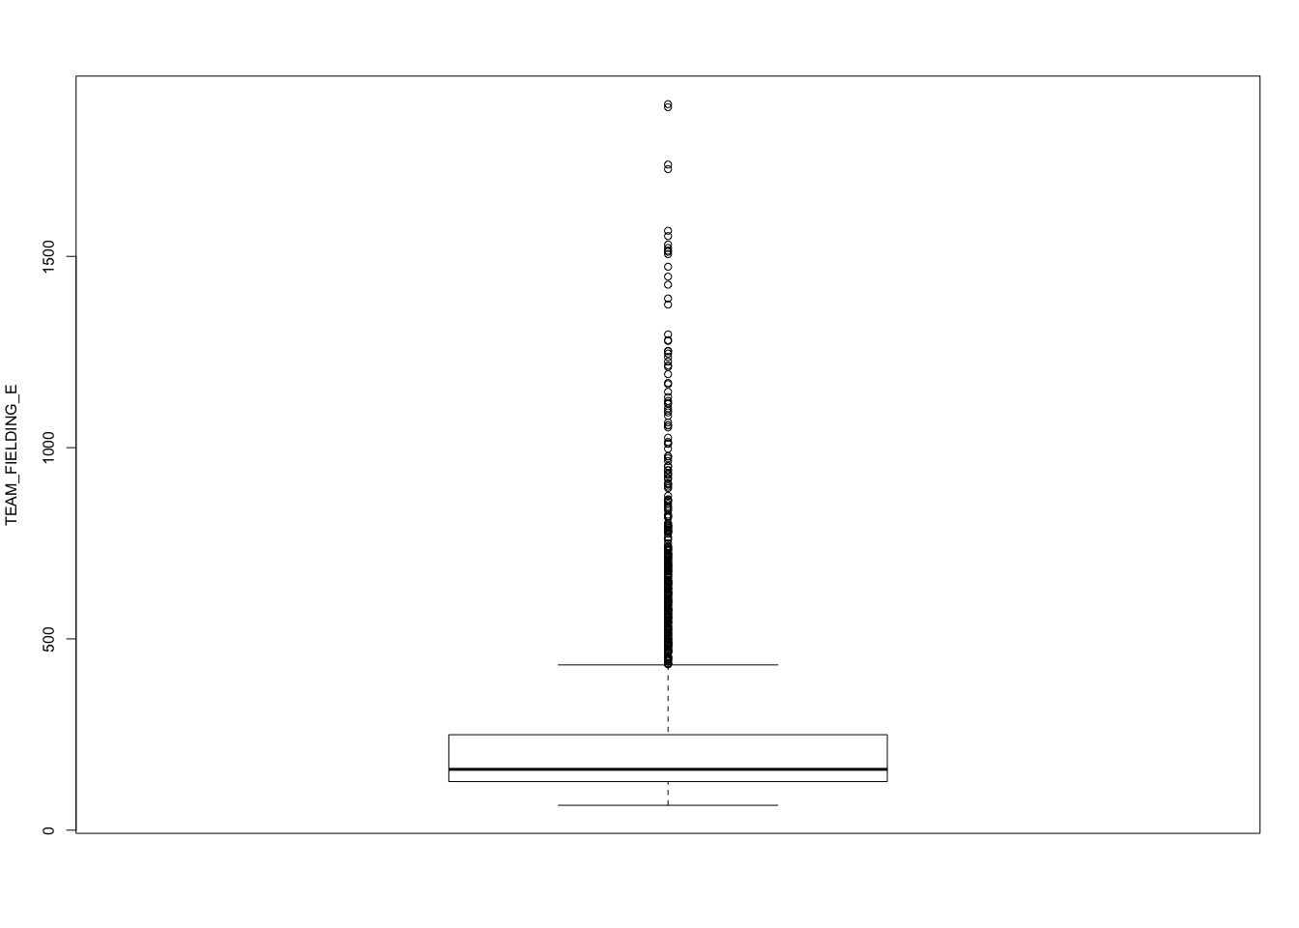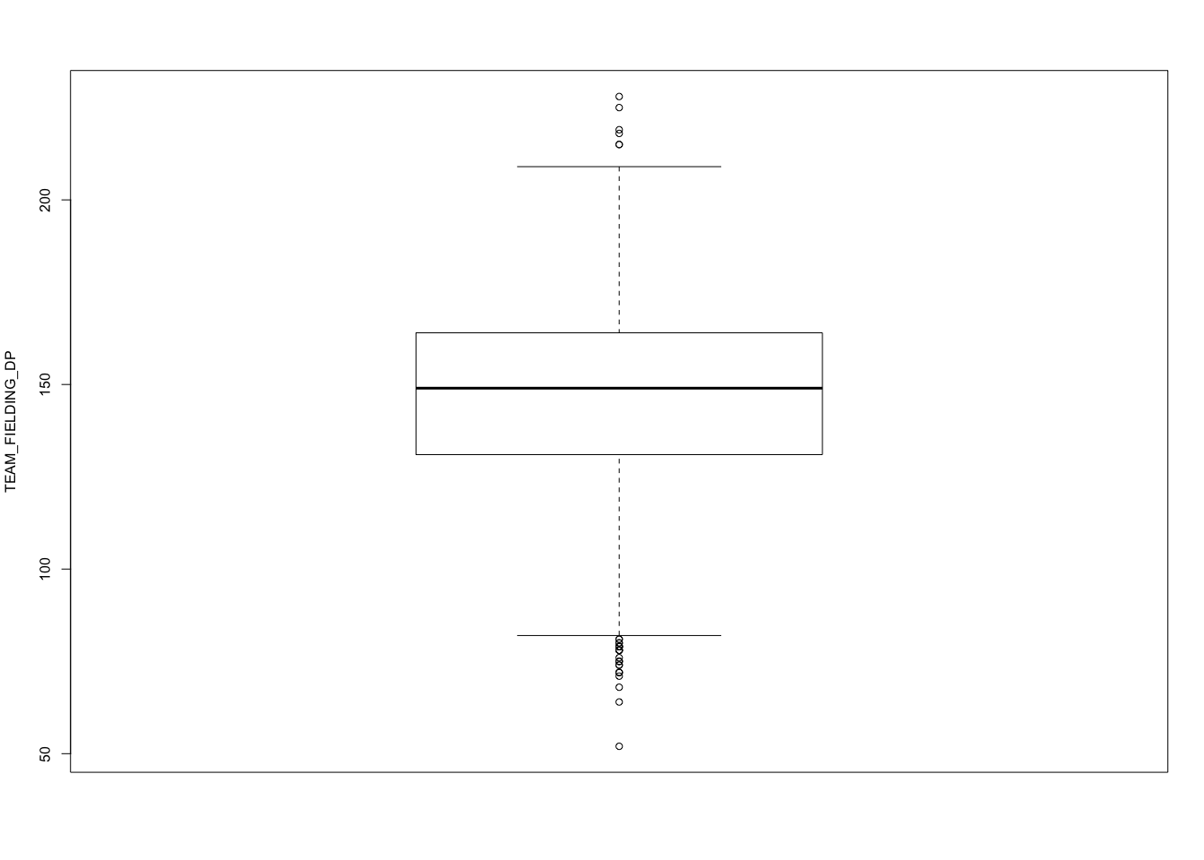

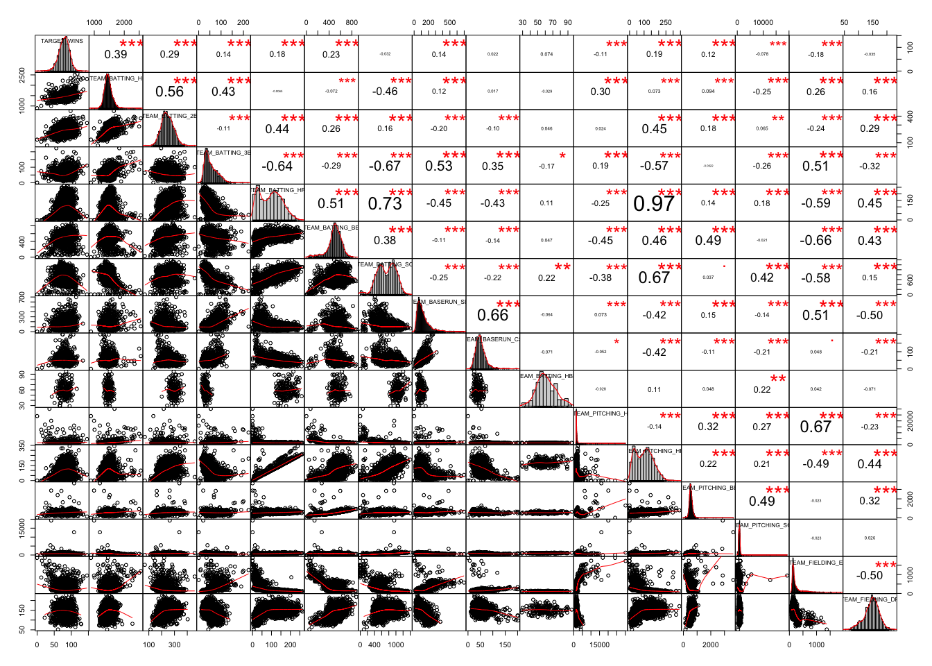

From the above plots histograms we can see that "TARGET_WINS" , "TEAM_BATTING_H" , "TEAM_BATTING_2B" ,"TEAM_BASERUN_CS" "TEAM_FIELDING_DP" are approximately normally distributed.

1,2,3,9,16

"TEAM_BATTING_3B" c"TEAM_BASERUN_SB" c"TEAM_BASERUN_CS", "TEAM_FIELDING_E"

are positively skewed. These variables have very few high values.

"TEAM_BATTING_HR" , "TEAM_BATTING_SO" , "TEAM_PITCHING_HR" has bi modal distributions. A large number of players scored two modes scores.

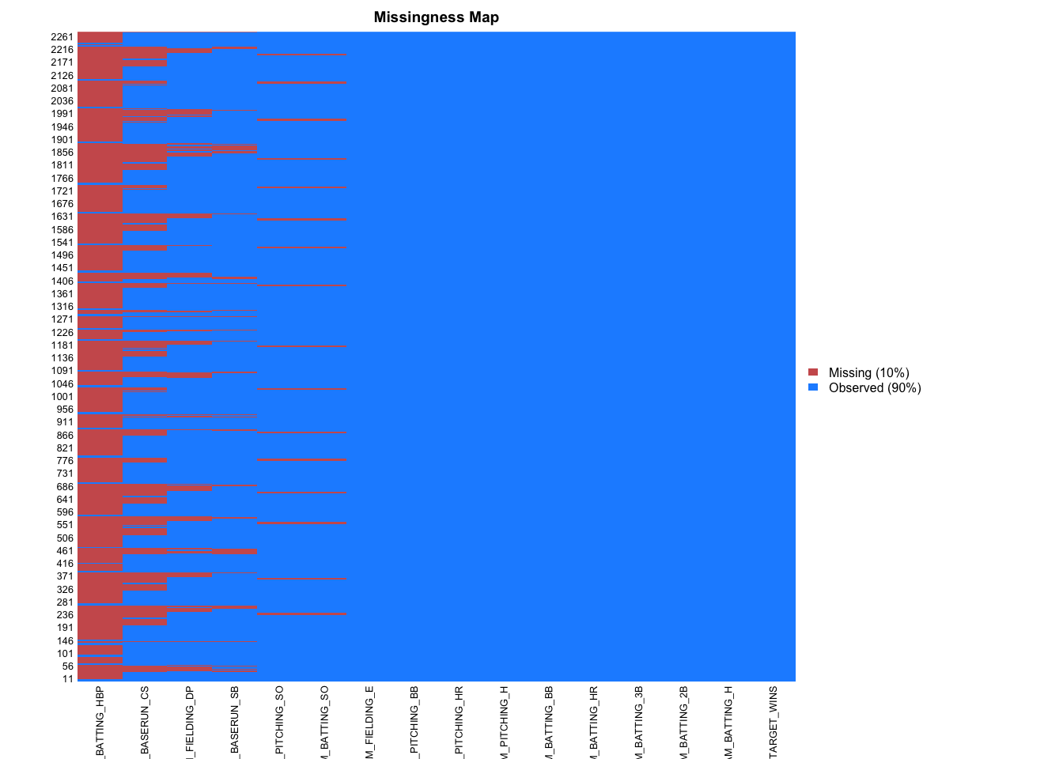 From the missing data plot we can see that 10% training data are missing. Most missings are in Team Batting HBP, Team BASERUN CS, Team Filding DP.

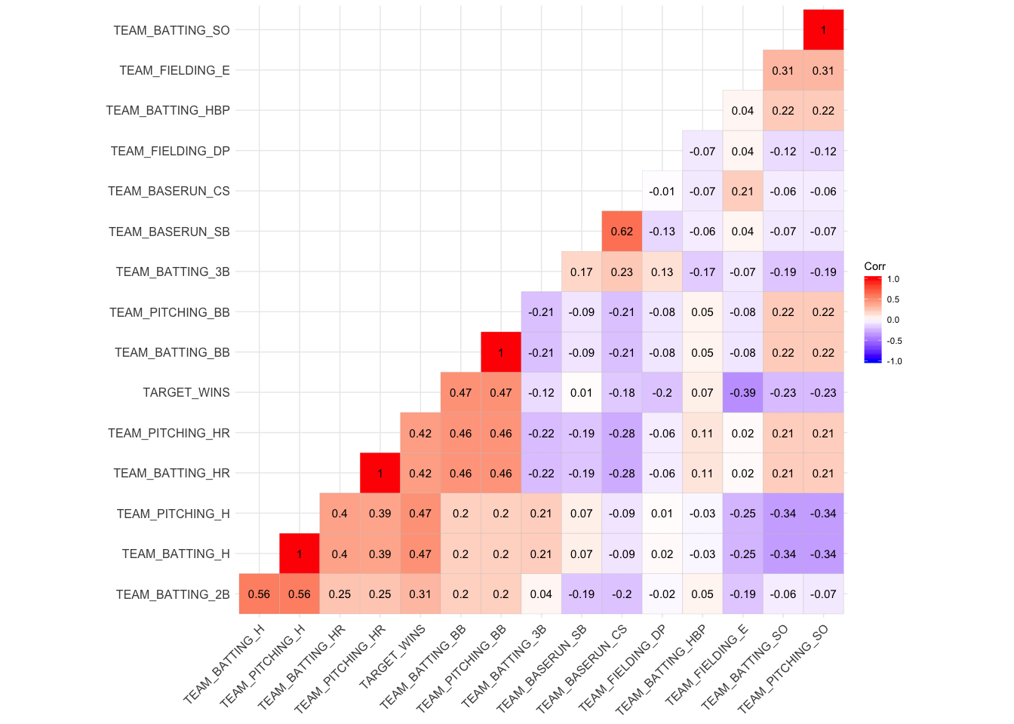

From the corrections matrix plot we can see that our Target Wins variable is highly positively correlated with Team Batting BB,Team Pitching BB and negatively correlated with Team Fielding E, Team Batting SO, Team Pitching SO.

# 2. DATA PREPARATION

a. Missing value imputation

Missing values were imputed using mice R package for both the training and test data set.

1. Create flags to suggest if a variable was missing

##   
## 0 1   
## 2085 191

From the flag we can see that 191 observations had missing values.

1. Transform data by putting it into buckets

I’ve transformed TEAM_BATTING_H into 3 buckets based on 0-1200,1200-2000,2000-3000. The new variable is TEAM_BATTING_H.cat. which has 3 categories Low, Medium,High. The old variable was dropped from the data set.

1. Combine variables (such as ratios or adding or multiplying) to create new variables

stolen variable was created summing TEAM_BASERUN_CS and TEAM_BASERUN_SB. Old two variables were dropped from the data.

# 3. BUILD MODELS

Model 1 with all the variables

|  |  |  |  |  |
| --- | --- | --- | --- | --- |
|  | Estimate | Std. Error | t value | Pr(>|t|) |
| **(Intercept)** | 66.51 | 4.338 | 15.33 | 1.544e-50 |
| **TEAM_BATTING_2B** | 0.04058 | 0.006974 | 5.818 | 6.8e-09 |
| **TEAM_BATTING_3B** | 0.0825 | 0.01582 | 5.216 | 1.992e-07 |
| **TEAM_BATTING_HR** | 0.1187 | 0.02747 | 4.32 | 1.625e-05 |
| **TEAM_BATTING_BB** | 0.01267 | 0.005732 | 2.21 | 0.02717 |
| **TEAM_BATTING_SO** | -0.0299 | 0.002299 | -13 | 2.445e-37 |
| **TEAM_BATTING_HBP** | 0.1591 | 0.02919 | 5.451 | 5.54e-08 |
| **TEAM_PITCHING_H** | 0.001164 | 0.0003972 | 2.931 | 0.00341 |
| **TEAM_PITCHING_HR** | 0.007045 | 0.02432 | 0.2896 | 0.7721 |
| **TEAM_PITCHING_BB** | -0.001544 | 0.00413 | -0.3739 | 0.7085 |
| **TEAM_PITCHING_SO** | 0.001794 | 0.0009085 | 1.975 | 0.04841 |
| **TEAM_FIELDING_E** | -0.04154 | 0.002752 | -15.09 | 4.159e-49 |
| **TEAM_FIELDING_DP** | -0.1157 | 0.01291 | -8.966 | 6.279e-19 |
| **TEAM_BATTING_H.catMedium** | 9.968 | 2.672 | 3.73 | 0.000196 |
| **TEAM_BATTING_H.catHigh** | 33.9 | 4.349 | 7.794 | 9.828e-15 |
| **stolen** | 0.039 | 0.003167 | 12.31 | 8.961e-34 |

Fitting linear model: TARGET_WINS ~ .

|  |  |  |  |
| --- | --- | --- | --- |
| Observations | Residual Std. Error |  | Adjusted |
| 2276 | 12.8 | 0.3437 | 0.3394 |
| Model 1 interpretations   |  | | --- | | For 1 unit increase in TEAM_BATTING_2B holding other things constant number of wins increases by  0.04058 units. | | For 1 unit increase in TEAM_BATTING_3B holding other things constant number of wins increases by  0.0825 units. | | For 1 unit increase in TEAM_BATTING_HR holding other things constant number of wins increases by  0.1187 units. | | For 1 unit increase in TEAM_BATTING_BB holding other things constant number of wins increases by  0.01267 units. | | For 1 unit increase in TEAM_BATTING_SO holding other things constant number of wins decreases by  0.0299 units. | | For 1 unit increase in TEAM_BATTING_HBP holding other things constant number of wins increases by  0.1591 units. | | For 1 unit increase in TEAM_PITCHING_H holding other things constant number of wins increases by  0.001164 units. | | For 1 unit increase in TEAM_PITCHING_HR holding other things constant number of wins increases by  0.007045 units. | | For 1 unit increase in TEAM_PITCHING_BB holding other things constant number of wins decreases by  0.001544 units. | | For 1 unit increase in TEAM_PITCHING_SO holding other things constant number of wins increases by  0.001794 units. | | For 1 unit increase in TEAM_FIELDING_E holding other things constant number of wins decreases by  0.04154 units. | | For 1 unit increase in TEAM_FIELDING_DP holding other things constant number of wins decreases by  0.1157 units. | | For 1 unit increase in TEAM_BATTING_H.catMedium holding other things constant number of wins increases by  9.968 units. | | For 1 unit increase in TEAM_BATTING_H.catHigh holding other things constant number of wins increase by  33.9 units. | | For 1 unit increase in stolen holding other things constant number of wins increase by  0.039 units. | |  |  |  |

Model 2 dropping non-significant variable

|  |  |  |  |  |
| --- | --- | --- | --- | --- |
|  | Estimate | Std. Error | t value | Pr(>|t|) |
| **(Intercept)** | 66.73 | 4.238 | 15.75 | 4.316e-53 |
| **TEAM_BATTING_2B** | 0.04177 | 0.006956 | 6.005 | 2.224e-09 |
| **TEAM_BATTING_3B** | 0.08301 | 0.01567 | 5.298 | 1.287e-07 |
| **TEAM_BATTING_HR** | 0.1232 | 0.00859 | 14.34 | 1.003e-44 |
| **TEAM_BATTING_BB** | 0.01074 | 0.00316 | 3.397 | 0.0006922 |
| **TEAM_BATTING_SO** | -0.02728 | 0.001968 | -13.86 | 5.645e-42 |
| **TEAM_BATTING_HBP** | 0.1582 | 0.02913 | 5.431 | 6.21e-08 |
| **TEAM_PITCHING_H** | 0.001484 | 0.0003129 | 4.744 | 2.225e-06 |
| **TEAM_FIELDING_E** | -0.04246 | 0.002718 | -15.62 | 2.54e-52 |
| **TEAM_FIELDING_DP** | -0.1157 | 0.01279 | -9.046 | 3.096e-19 |
| **TEAM_BATTING_H.catMedium** | 8.906 | 2.622 | 3.396 | 0.0006944 |
| **TEAM_BATTING_H.catHigh** | 31.66 | 4.123 | 7.678 | 2.392e-14 |
| **stolen** | 0.03984 | 0.003069 | 12.98 | 3.197e-37 |

Fitting linear model: TARGET_WINS ~ . - TEAM_PITCHING_HR - TEAM_PITCHING_BB - TEAM_PITCHING_SO

|  |  |  |  |
| --- | --- | --- | --- |
| Observations | Residual Std. Error |  | Adjusted |
| 2276 | 12.81 | 0.3421 | 0.3386 |

Model 2 interpreations

|  |
| --- |
| For 1 unit increase in TEAM_BATTING_2B holding other things constant number of wins increases by  0.04177 units. |
| For 1 unit increase in TEAM_BATTING_3B holding other things constant number of wins increases by  0.08301 units. |
| For 1 unit increase in TEAM_BATTING_HR holding other things constant number of wins increases by  0.1232 units. |
| For 1 unit increase in TEAM_BATTING_BB holding other things constant number of wins increases by  0.01074 units. |
| For 1 unit increase in TEAM_BATTING_SO holding other things constant number of wins decreases by 0.02728 units. |
| For 1 unit increase in TEAM_BATTING_HBP holding other things constant number of wins increases by  0.1582 units. |
| For 1 unit increase in TEAM_PITCHING_H holding other things constant number of wins increases by  0.001484 units. |
| For 1 unit increase in TEAM_FIELDING_E holding other things constant number of wins decreases by  0.04246 units. |
| For 1 unit increase in TEAM_FIELDING_DP holding other things constant number of wins decreses by  0.1157 units. |
| For 1 unit increase in TEAM_BATTING_H.catMedium holding other things constant number of wins increases by  8.906 units. |
| For 1 unit increase in TEAM_BATTING_H.catHigh holding other things constant number of wins increases by  31.66 units. |
| For 1 unit increase in stolen holding other things constant number of wins increases by  0.03984 units. |

Model 3 with highly correlated variables

|  |  |  |  |  |
| --- | --- | --- | --- | --- |
|  | Estimate | Std. Error | t value | Pr(>|t|) |
| **(Intercept)** | 40.83 | 3.45 | 11.83 | 2.141e-31 |
| **TEAM_BATTING_H.catMedium** | 14.47 | 2.954 | 4.899 | 1.032e-06 |
| **TEAM_BATTING_H.catHigh** | 41.4 | 4.69 | 8.827 | 2.102e-18 |
| **TEAM_BATTING_2B** | 0.07106 | 0.00758 | 9.374 | 1.626e-20 |
| **TEAM_BATTING_HR** | -0.07093 | 0.02402 | -2.953 | 0.003178 |
| **TEAM_BATTING_BB** | 0.0215 | 0.003164 | 6.794 | 1.39e-11 |
| **TEAM_PITCHING_H** | -0.001288 | 0.0002817 | -4.574 | 5.033e-06 |
| **TEAM_PITCHING_HR** | 0.06504 | 0.02306 | 2.82 | 0.004838 |

Fitting linear model: TARGET_WINS ~ TEAM_BATTING_H.cat + TEAM_BATTING_2B + TEAM_BATTING_HR + TEAM_BATTING_BB + TEAM_PITCHING_H + TEAM_PITCHING_HR

|  |  |  |  |
| --- | --- | --- | --- |
| Observations | Residual Std. Error |  | Adjusted |
| 2276 | 14.53 | 0.1515 | 0.1489  Model 3 interpretations   |  | | --- | | For 1 unit increase in TEAM_BATTING_H.cat Medium holding other things constant number of wins increase by  14.47 units. | | For 1 unit increase in TEAM_BATTING_H.catHigh holding other things constant number of wins increase by  41.4 units. | | For 1 unit increase in TEAM_BATTING_2B holding other things constant number of wins increase by  0.07106 units. | | For 1 unit increase in TEAM_BATTING_HR holding other things constant number of wins decreses by  0.07093 units. | | For 1 unit increase in TEAM_BATTING_BB holding other things constant number of wins increase by  0.0215 units. | | For 1 unit increase in TEAM_PITCHING_H holding other things constant number of wins decerses by  0.001288 units. | | For 1 unit increase in TEAM_PITCHING_HR holding other things constant number of wins increase by  0.06504 units. | |

# 4. SELECT MODELS

Decide on the criteria for selecting the best multiple linear regression model. Will you select a model with slightly worse performance if it makes more sense or is more parsimonious?

I’ve selected model 2 as the best model with slightly worse performance as it’s simpler than other is more parsimonious. From the residuals plots of the 3 plots we can see that the residuals of the model 3 is more normally distributed than other models.

Discuss why you selected your model. For the multiple linear regression model, will you use a metric such as Adjusted R2, RMSE, etc.?

For multiple regression model we can use Adjusted R2,RMSE etc as here the dependent variable is continuous.

Be sure to explain how you can make inferences from the model, discuss multi-collinearity issues (if any), and discuss other relevant model output.

Here multicollinearity is eliminated by removing two highly correlated variables in the traihing and evaluation data.

Using the training data set, evaluate the multiple linear regression model based on

1. mean squared error

model 1 has the lowest mean squared error.

## [1] 162.7660 163.1656 210.4413

1. R2

Model 1 has highest Adjusted R2 , model 2 slightly lower and model 3 worst performer here.

## [1] 0.3393862

## [1] 0.338642

## [1] 0.1489004

1. F-statistic

Based on f statistics model 2 is the best model

## value numdf dendf   
## 78.91779 15.00000 2260.00000

## value numdf dendf   
## 98.07433 12.00000 2263.00000

## value numdf dendf   
## 57.85895 7.00000 2268.00000

(d) residual plots.

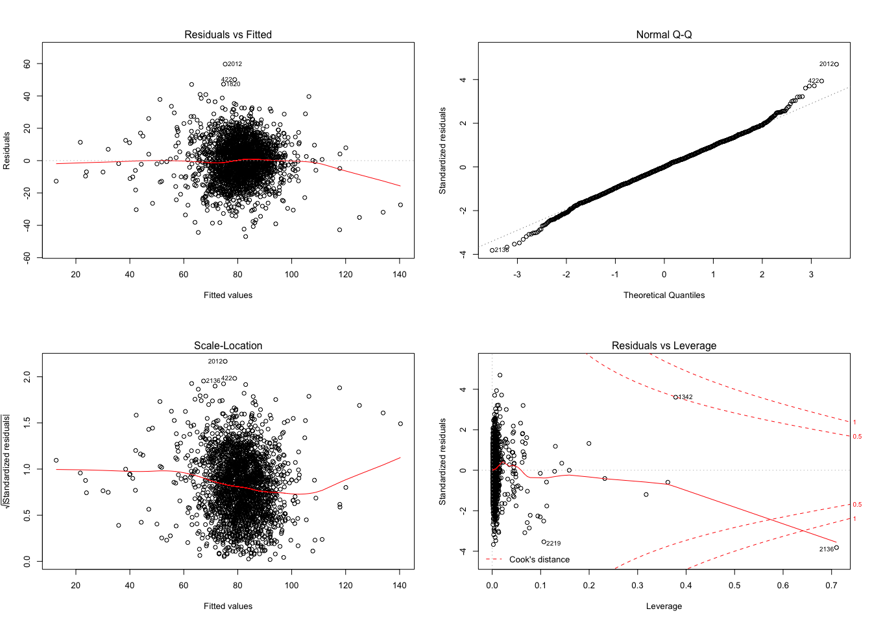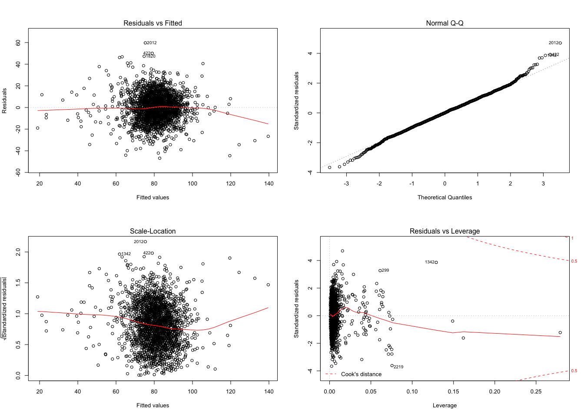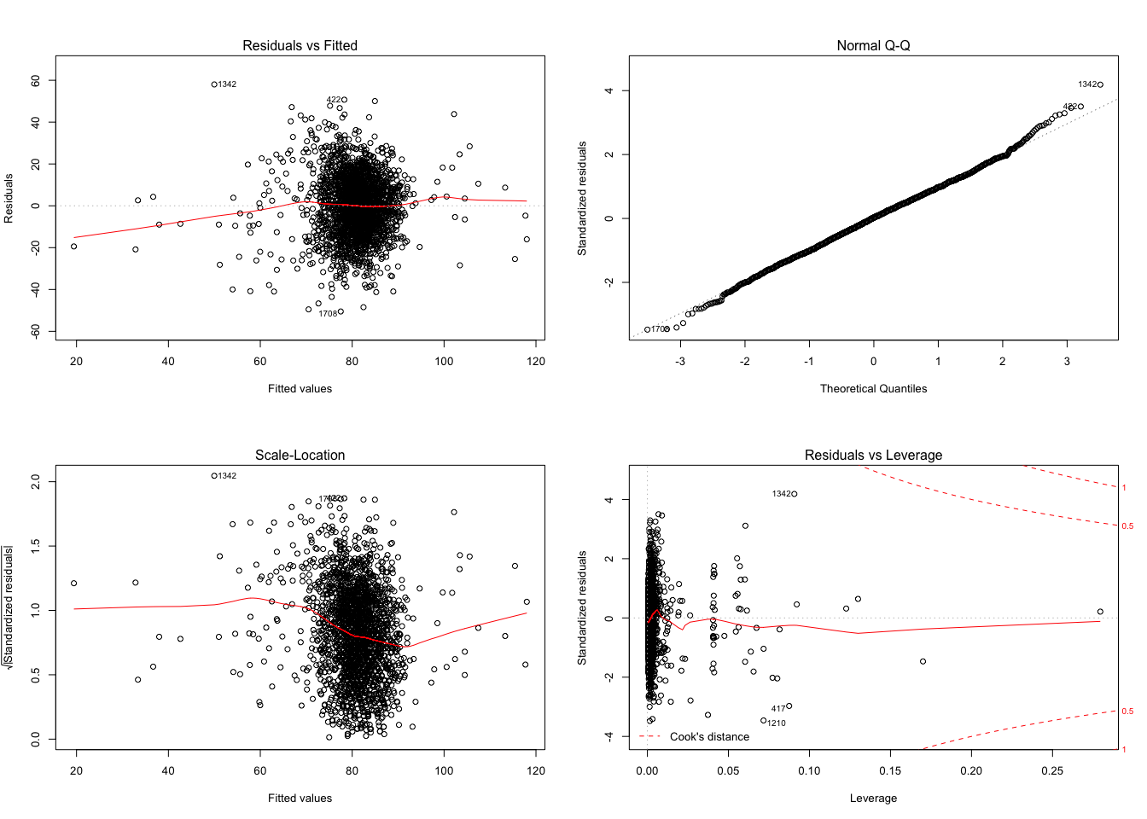

Predicted values based on evaluation data.

Make predictions using the evaluation data set.

## [1] 68.48767 71.38504 72.12317 84.83438 70.16620 68.73464 85.68734  
## [8] 76.00445 75.85849 78.19033 72.68052 87.01893 86.71197 88.03763  
## [15] 88.13696 83.66940 75.79230 78.40343 74.22339 95.33227 83.22888  
## [22] 82.78867 82.06625 76.80082 80.28384 88.24047 62.91863 84.15983  
## [29] 85.86068 78.14723 92.96408 85.83207 81.48234 81.11226 79.82247  
## [36] 88.57711 78.00640 91.44307 84.99535 87.58912 85.06656 89.37659  
## [43] 28.54820 98.15649 91.91464 94.94144 95.22529 86.08178 72.61789  
## [50] 92.37001 80.60373 90.31735 74.78800 77.31880 72.74980 76.98705  
## [57] 94.45525 83.10520 59.88745 80.02173 91.12336 76.47366 84.50786  
## [64] 89.88557 89.66803 102.97966 73.05131 79.37974 78.73432 88.57108  
## [71] 86.60946 75.03791 79.20755 97.31598 72.64560 76.23734 80.50222  
## [78] 83.83428 80.70453 83.93743 92.00608 89.36467 99.35351 80.38606  
## [85] 83.57266 83.57485 88.09016 82.07539 88.44194 93.52788 86.79906  
## [92] 80.78706 79.16872 93.60227 91.40149 91.19427 89.05885 98.27534  
## [99] 85.97692 89.54876 83.29764 77.68317 85.97774 82.52179 74.82078  
## [106] 70.70175 57.51297 79.36434 89.55668 60.99673 87.78159 94.73241  
## [113] 89.89639 88.85225 82.97740 81.25010 84.63588 84.04608 74.47662  
## [120] 80.09763 101.91647 80.97909 76.04747 71.33448 72.16930 91.94506  
## [127] 87.90748 83.36340 100.10939 90.71871 89.80031 84.93343 80.72216  
## [134] 79.57090 86.32260 82.13408 78.75019 79.79763 87.18288 80.05348  
## [141] 67.41627 80.10535 92.25060 73.38117 72.96425 75.61461 81.81643  
## [148] 77.30022 76.60572 84.41243 86.27781 80.18331 42.80567 69.74522  
## [155] 72.52029 70.95859 93.45498 72.35090 90.11417 82.30247 100.44653  
## [162] 103.07066 95.47314 100.96040 96.90498 94.47721 80.85722 91.78653  
## [169] 74.71601 83.73195 91.25980 89.58270 83.14932 95.65323 88.45345  
## [176] 77.94737 80.80159 72.14018 73.38385 80.19481 92.12023 88.78278  
## [183] 85.64648 88.45839 99.82228 99.32677 79.57212 61.82762 72.66872  
## [190] 131.76888 79.13778 89.45419 81.33148 79.67157 79.94568 71.72765  
## [197] 81.98435 89.47627 82.25859 79.79352 74.24921 73.40594 72.34378  
## [204] 96.59306 82.33178 83.00158 74.15658 78.11323 85.95968 76.65071  
## [211] 105.15990 89.00342 87.44518 67.67453 78.89580 81.53157 74.68869  
## [218] 91.57693 75.90977 79.24671 77.60802 79.39687 82.71303 77.98005  
## [225] 79.38975 81.22994 79.70342 76.84217 81.10108 72.15632 86.53929  
## [232] 95.59687 80.58169 88.47550 80.14375 77.55778 75.43614 81.23768  
## [239] 96.87252 75.12678 90.51053 91.18343 84.84442 79.27575 53.34976  
## [246] 87.15169 82.81757 87.13769 77.96667 86.75250 80.17237 55.86816  
## [253] 86.73627 19.26033 69.82397 77.22468 84.44193 88.83353 79.40591

* Appendix.

## ------------------------------------------------------------------------

library(ggcorrplot)

library(pander)

library(tidyverse)

library(PerformanceAnalytics)

library(Amelia)

library(caret)

library(mice)

## ------------------------------------------------------------------------

training <- read_csv("moneyball-training-data.csv" )

training <- training[,2:ncol(training)]

evaluation <- read_csv("moneyball-evaluation-data.csv")

colId <- evaluation$INDEX

evaluation <- evaluation[,2:ncol(evaluation)]

## ------------------------------------------------------------------------

glimpse(training)

## ------------------------------------------------------------------------

pander(summary(training), split.table=120)

## ------------------------------------------------------------------------

for(col in colnames(training)){

boxplot(training[,col],ylab = col)

}

## ------------------------------------------------------------------------

chart.Correlation(training)

## ------------------------------------------------------------------------

missmap(training)

## ------------------------------------------------------------------------

corr <- cor(training, use="complete.ob")

ggcorrplot(corr, hc.order = TRUE, type = "lower",

lab = TRUE)

## ------------------------------------------------------------------------

imputed_Data <- mice(training, m=1, maxit = 50, method = 'pmm', seed = 500)

complete_data <- complete(imputed_Data,1)

imputed_Data_eval <- mice(evaluation, m=1, maxit = 50, method = 'pmm', seed = 500)

complete_data_evaluation <- complete(imputed_Data_eval,1)

## ------------------------------------------------------------------------

training$flag <- 0

training$flag[rowMeans(training) > 0] <- 1

table(training$flag)

## ------------------------------------------------------------------------

# TEAM_BATTING_H 0-1200,1200-2000,2000-3000

b <- c(-Inf, 1200, 2000, Inf)

names <- c("Low", "Medium", "High")

complete_data$TEAM_BATTING_H.cat <- cut(complete_data$TEAM_BATTING_H, breaks = b, labels = names)

complete_data_evaluation$TEAM_BATTING_H.cat <- cut(complete_data_evaluation$TEAM_BATTING_H, breaks = b, labels = names)

## ------------------------------------------------------------------------

complete_data$stolen <- complete_data$TEAM_BASERUN_CS + complete_data$TEAM_BASERUN_SB

complete_data_evaluation$stolen <- complete_data_evaluation$TEAM_BASERUN_CS + complete_data_evaluation$TEAM_BASERUN_SB

## ------------------------------------------------------------------------

# drop TEAM_BATTING_H

complete_data <- complete_data %>%

select(-TEAM_BATTING_H,-TEAM_BASERUN_CS, -TEAM_BASERUN_SB)

# drop TEAM_BATTING_H

evaluation <- evaluation %>%

select(-TEAM_BATTING_H,-TEAM_BASERUN_CS, -TEAM_BASERUN_SB)

## ------------------------------------------------------------------------

model1 <- lm(TARGET_WINS~., data = complete_data)

pander(summary(model1))

## ------------------------------------------------------------------------

model2 <- lm(TARGET_WINS~.-TEAM_PITCHING_HR-TEAM_PITCHING_BB-TEAM_PITCHING_SO, data = complete_data)

pander(summary(model2))

## ------------------------------------------------------------------------

model3 <- lm(TARGET_WINS~TEAM_BATTING_H.cat+TEAM_BATTING_2B +TEAM_BATTING_HR + TEAM_BATTING_BB+

TEAM_PITCHING_H+TEAM_PITCHING_HR, data = complete_data )

pander(summary(model3))

## ------------------------------------------------------------------------

mse <- numeric(3)

mse[[1]] <- mean((complete_data$TARGET_WINS - predict(model1))^2)

mse[[2]] <- mean((complete_data$TARGET_WINS - predict(model2))^2)

mse[[3]] <- mean((complete_data$TARGET_WINS - predict(model3))^2)

mse

## ------------------------------------------------------------------------

summary(model1)$adj.r.squared

summary(model2)$adj.r.squared

summary(model3)$adj.r.squared

## ------------------------------------------------------------------------

summary(model1)$fstatistic

summary(model2)$fstatistic

summary(model3)$fstatistic

## ------------------------------------------------------------------------

par(mfrow=c(2,2))

plot(model1)

par(mfrow=c(2,2))

plot(model2)

par(mfrow=c(2,2))

plot(model3)

## ------------------------------------------------------------------------

complete_data_evaluation$PredictedWins <- predict(model2, complete_data_evaluation)

complete_data_evaluation$PredictedWins

## ------------------------------------------------------------------------

df <- data.frame("Index"=colId,"Predicted wins"= complete_data_evaluation$PredictedWins)

write.csv(df,"predictions.csv")